Experiment-8
Name:S Lakshan Rollno:240701281

Create storyboards to represent the user flow for your application using Balsamiq

Aim
To design and prototype a user-friendly wireframe for a Cinema Movie Ticket Booking Application using Balsamiq, representing the complete user workflow in a single combined view.

Tools Used
- Balsamiq (Wireframing Tool)

Description
This project presents a cinema movie ticket booking application interface designed using Balsamiq. Instead of creating separate screens, all major steps of the booking workflow are combined into a single image to clearly visualize the entire process.

The combined wireframe includes movie browsing, movie details, seat selection, and payment & confirmation, providing a complete overview of the user journey from selecting a movie to booking a ticket.

Wireframe
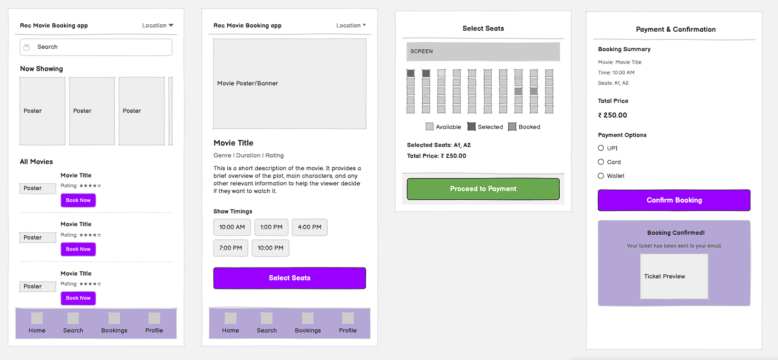

Explanation of the Wireframe
The combined wireframe represents the full workflow of the cinema ticket booking application:

- Home / Movie Listing Section
- Users can browse movies under “Now Showing”
- Search bar helps to find movies quickly
- Movies are shown with posters and a “Book Now” option

- Movie Details Section
- Displays movie details like title, genre, and rating
- Shows a short description
- Users can select show timings and proceed

3. Seat Selection Section
- Shows seat layout with available and booked seats
- Users can select seats and view total price
- Option to proceed to payment

4. Payment & Confirmation Section
- Displays booking summary and total amount
- Provides payment options (UPI, Card, Wallet)
- Booking is confirmed with a ticket preview

Conclusion
The combined wireframe effectively represents the entire movie ticket booking process in a single view. It helps in understanding the flow of the application and user interactions across different stages, making it easier to design and develop a user-friendly cinema booking system.

Wireframe Link: https://balsamiq.cloud/s5qa6qr/pxgebw7

